

**Name…………………………………………………………… ADM Number:……………..**

**School:…...……….............................. Candidate’s Signature……………...…………..**

**121/1**

**Mathematics Alt.A**

**FORM FOUR.**

**JULY 2ND 2024.**

**2 ½ Hours.**

**URANGA MATHEMATICS ASSOCIATION-2024.**

**Kenya Certificate of Secondary Education**

**MATHEMATICS 121/1**

**FORM FOUR**

**TIME: 2 ½ HOURS**

**INSTRUCTIONS TO CANDIDATES:**

* Write your name, school, admission number and sign in the spaces provided above.
* This paper contains **TWO** sections: Section **I** and Section **II**.
* Answer **ALL** the questions in Section **I** and **FIVE** questions from section **II**.
* All answers and working **MUST** be written on the question paper in the spaces provided below each question.
* Marks may be given for correct working even if the answer is wrong.
* Non-programmable silent electronic calculators and KNEC Mathematical tables may be used, except where stated otherwise.

**FOR EXAMINERS USE ONLY**

**SECTION I**

|  |  |  |  |  |  |  |  |  |  |  |  |  |  |  |  |  |
| --- | --- | --- | --- | --- | --- | --- | --- | --- | --- | --- | --- | --- | --- | --- | --- | --- |
| **1** | **2** | **3** | **4** | **5** | **6** | **7** | **8** | **9** | **10** | **11** | **12** | **13** | **14** | **15** | **16** | **Total** |
|  |  |  |  |  |  |  |  |  |  |  |  |  |  |  |  |  |

**SECTION II**

**Grand Total**

|  |  |  |  |  |  |  |  |  |
| --- | --- | --- | --- | --- | --- | --- | --- | --- |
| **17** | **18** | **19** | **20** | **21** | **22** | **23** | **24** | **Total** |
|  |  |  |  |  |  |  |  |  |

*This paper consists of 15 printed pages. Candidates should check to ascertain that all pages are printed as indicated and that no questions are missing.*

# SECTION I (50 MARKS)

**Answer All the Questions in this section.**

1. Simplify without using calculators  (3 marks)

2. Use tables of reciprocals and square roots to evaluate;

- (3 marks)

3. The interior angle of a regular polygon is 300 more than four times the exterior angle. Find the

number of sides of the polygon. (3 marks)

4. A company sales lady sold goods worth Ksh. 360,000 but gave a discount of 2.5%, if she is

paid a commission of 8% on her sales and her basic salary of Ksh. 12,000, calculate her

earnings in that month. (3 marks)

5. Given the curve y = x3 + 2x2 – 6x + 1. Find the equation of the normal to the curve at x = 1. (3 marks)

6. A surveyor recorded the information about a tea farm in his field book as in the table below.

Q

600 90 to C

To A 180 420

300 90 to D

To B 50 50

P

Find the area of the field in hectares. (3 marks)

7. On the grid below, draw a histogram to represent the following distribution. (3 marks)

|  |  |  |  |  |
| --- | --- | --- | --- | --- |
| **Length (cm)** | 1 – 5 | 6 – 15 | 16 – 30 | 31 – 40 |
| **Frequency** | 2 | 9 | 10 | 8 |



8. A cylindrical container of radius 14cm has water to depth of 24cm. when a rectangular block

of side 4 cm by 6 cm by *x* cm is immersed inside the water completely the water level rises to

a depth of 24.5cm; Find the value of *x* to one decimal place. Take  (4 marks)

9. Find the value of *x* which satisfies the equation.  (3 marks)

10. A bus takes 40 minutes, 45 minutes and 48 minutes to travel from town P to town S via

towns Q and R respectively. If the bus is to arrive in town S on Tuesday 1.13 a.m., find the

time it should depart from town P. (3 marks)

11. A well wisher distributed his computers as follows: A certain hospital received a quarter of

the total number of computers, a nearby school received a half of the remainder and a self

help group received a third of what the school received. What remained were six computers

more that the self help group received. How many computers did the well wisher have? (4 marks)

12. Draw a line AB 12cm long. Using ruler, set square and compasses only, construct the point X

which divides the line AB internally in the ratio 5:3. measure AX. (3 marks)

13. Using mid-ordinate rule with four strips, estimate the area bounded by the curve

y = 2x + 3x2, the x – axis, the lines x = 0 and x = 2. (3 marks)

14. If Tan A = ¾, show that Cos2 A + Sin 2 A = 1 (3 marks)

15. On the grid below show the region R defined by the following inequalities. (3 marks)

x + 1 ≥ 0

x+ y ≤ 5

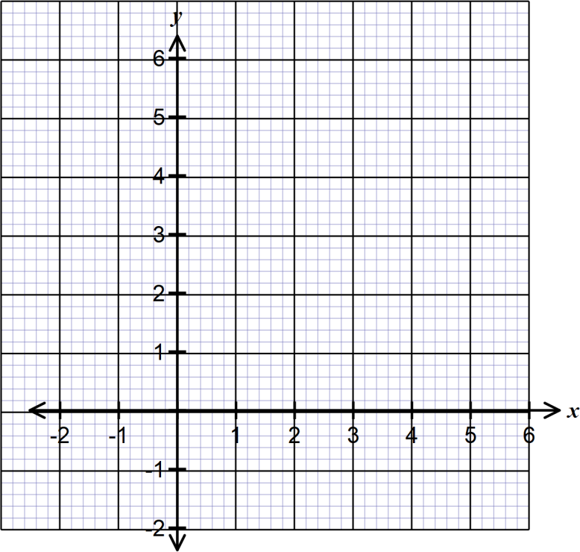 y − x > −1

16. The figure below shows a solid beacon used in road construction. Complete the beacon,

showing all the hidden lines. (3 marks)

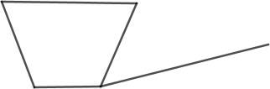

# SECTION II (50 MARKS)

**Answer ONLY 5 Questions in this Section**

17. Water flows through a pipe of internal radius of 3.5cm at 9 metres per second into a storage

tank of rectangular base of 12m by 8m.

Calculate

a) The volume of water delivered into the tank in one minute in litres. (2 marks)

b) The capacity of water in litres that is consumed by a village of 435 families that

depend on this water, in one week, if each family consumes an average of six jericans

of 20 litres each per day. (2 marks)

c) The minimum height of the water level in the storage tank that will ensure that the

village doesn’t suffer from water shortage within the week. (2 marks)

d) How long will it take the pipe to fill the tank to that level giving your answer in hours.

(2 marks)

e) Calculate the monthly bill of the village if the cost of water is Kshs.1.50 per jelican

(take a month of 30 days) (2 marks)

18. A marble is projected up and after t seconds its distance from the starting point is S metres

where S = 24t – 3t2.

(i) Find the distance covered after 8 seconds. (2 marks)

(ii) What is the velocity after 8 seconds? (2 marks)

(iii) What is its initial velocity? (2 marks)

(iv) After how many seconds does it reach its farthest point? (2 marks)

(v) What is its acceleration? (2 marks)

19. Two intersecting circles have centers P and Q as shown below. The circle centre P has radius

8cm and that of centre Q has radius 9cm.

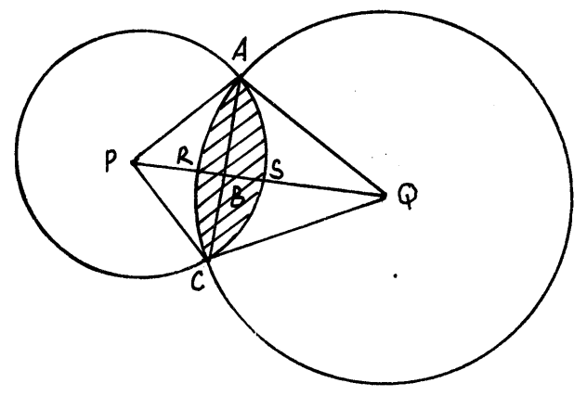

The distance between the centers PQ = 14cm and PB: BQ = 3:4.

Calculate:

(i) Angle APC (2 marks)

(ii) Angle AQC (2 marks)

(iii) The area of the shaded region (6 marks)

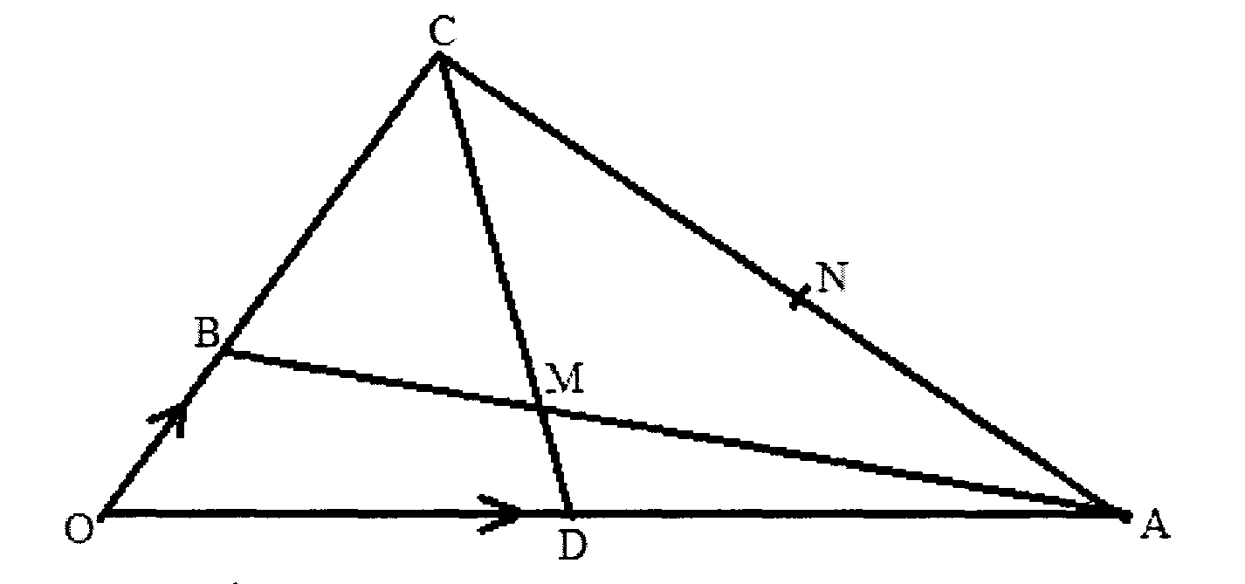20. In the figure below **OB** = b , **OC** =3**OB** and **OA** = a

~

~

(a) Given that **OD**= **OA** and **AN**=**AC**, **CD** and **AB** meet at **M**.

(i) Determine in terms of **a** and **b** vector **AB** (1 mark)

~

~

(ii) Determine in terms of **a** and **b** vector **CD** (1 mark)

~

~

(b) Given that **CM**=k**CD** and **AM** =h**AB**, determine the values of the scalars **k** and **h**.

(5 marks)

(c) Show the **O**, **M** and **N** are collinear. (3 marks)

21. a) A bus travelling at 99km/hr passes a checkpoint at l0.00am and a matatu travelling at

132km/hr in the same direction passes through the check point at 10.l5am. If the bus and

the matatu continue at their uniform speeds, find the time the matatu will overtake the bus. (6 marks)

b) Two passenger trains A and B which are 240m apart and travelling in opposite

directions at 164km/h and 88km/h respectively approach one another on a straight

railway line. Train A is 150 metres long and train B is 100m long. Determine the time

in seconds that elapses before the two trains completely pass each other. (4 marks)

22. The vertices of triangle **PQR** are **P** (0,0). **Q**(6, 0) and **R**(2,4)

(a) Draw triangle **PQR** on the grid provided. (l mark)



(b) Triangle **P1Q1R1** is the image of a triangle **PQR** under an enlargement scale factor ½ and centre (2,2). Write down the coordinates of triangle **P1Q1R1**and plot on the same grid. (3 marks)

(c).Draw triangle **P11Q11R11**  the image of triangle **P1Q1R1** under a positive quarter turn about points. (1, 1). (2 marks)

(d).Draw a triangle **P111Q111R111** the image of triangle **P11Q11R11** under reflection in the line **y** =1.

(2 marks)

(e). Describe fully a single transformation that maps triangle **P111Q111R111** onto triangle **P1Q1R1.** (2 marks)

23. (a) Find the inverse of the matrix: (2 marks)

**A**= 

(b) Rose bought 20 bags of oranges and 15 bags of mangoes for a total of sh. 9,500. Chumo

bought 30 bags of oranges and 20 bags of mangoes for a total of sh. 13,500. If the price of a

bag of oranges is **x** and that of mangoes is **y**:

(i) Form two simplified equations to represent the information above. (2 marks)

(ii) Hence use the matrix **A-1** above to find the price of one bag of each item (3 marks)

(c) The price of each bag of oranges was increased by 10% and that of mangoes reduced by 10%.

The businesswomen (Rose and Chumo) bought as many oranges and as many mangoes as they bought earlier. Find by matrix method the total cost of oranges and mangoes that the businesswomen bought after the percentage change. (3 marks)

24.a) Determine the stationery points of the curve *y*  *x*2 3  *x*                                (3 marks)

b) For each of the stationery points in (a) above determine their nature. (2 marks)

c) Determine the x and y intercepts of the curve y  x2 3  x                                      (3 marks)

d) Sketch the curve y  x2 3  x in the space below. (2 marks)